Title: | Door Control Module  SW Architecture DoorControlModule

History
Issue status  (Index) | Maturity/Date  (draft/invalid/valid)  (dd-mmm-yyyy) | Author  Department | Check/Release  Department | Description
1.0 | Draft  21-Ene-21 | Marco Valdez | Marco Valdez | Creation of the document

Table of Contents
1 Purpose 3
2 Definitions and abbreviations 3
3 Realization constraints and targets 3
4 SW Functional Architecture 3
4.1 Table of functions 3
4.2 Table of functional Interfaces 4
4.3 Functional Interface 4
4.4 Functional Interaction 4
5 SW Physical Architecture 5
5.1 Physical Decomposition 5
5.2 Table of SW components 5
5.3 Table of Physical Interfaces 5
5.4 Physical Interfaces 6
5.5 Physical Interaction 6
5.6 Describe Dynamic Behavior 6
5.6.1 OS tasks 6
5.6.2 Interrupt Handling 6
5.6.3 Power Modes 7
5.7 Synchronization Mechanisms 7
6 Function to Physical Allocation 7
7 SW Requirements Allocation 8
8 SW Integration Plan 8
9 Functional Safety 8

Purpose
This document stablishes the functional and physical architecture of a Door Control Module.

Definitions and abbreviations
Definitions
AntiPinch | Function that avoids smashing objects while a window operation

Abbreviations

BTN – Button
SW – Software
HWW – Hardware
References
N° | Document name | Reference
1 | TraceabilityMatrixTemplate.xls | https://github.com/marcovc41/Proyecto_Diplomado/blob/master/V-Cycle%20Process/1.0%20Requirements/Traceability%20Matrix%20Template.xls

Realization constraints and targets

These functionalities allow to control the DriverDoor, PassengerDoor, RearRight Door and RearLeft Door of a vehicle.
Main functionalities for the system include:
- Door Locking
- Window Control
- HW Diagnostics

SW Functional Architecture

Table of functions
Function Name | Description
DetermineButtonStatus | Checks the button status and identifies the kind of button press.
DetermineWindowPosition | Determines the current window position.
DetermineDoorStatus | Determines the doors current status.
DetermineVehicleSpeed | Requests the vehicle speed.
DetermineSystem  PowerMode | Determines if the vehicle is in run mode.
CheckDoorConditions | Determines the action to take with the door, according to the current status and inputs.
CheckWindowConditions | Determines the action to take with the window, according to the current status and inputs.
WindowControl | Controls the dc motor to open and close an specific window.
DoorLocking | Controls the solenoid to lock or unlock a specific door.
AntiPinchActivation | Reports an antipinch event.
MessageManagement | Reports system status and identify remote operations.
ErrorHandling | Determines the action to take when an error is detected.

Table of functional Interfaces
Signal/Event | Description
ButtonStatus | Represents the type of interaction with the button (short press, long press, button stuck or no action)
ButtonPressed | Indicates which button was pressed
WindowPosition | Current window position.
DoorStatus | Door current status.
VehicleSpeed | Vehicle current speed.
SystemPowerMode | Vehicle run state.
RemoteWindowCommand | Indicates that a window remote operation was requested.
RemoteDoorCommand | Indicates that a door remote operation was requested.
AntiPinchSignal | Indicates an antipinch event.
MoveWindow | Request a new window position.
MoveDoor | Request door locking or unlocking.
WindowError | Indicates a window error.
DoorError | Indicates a door error.
ReportWindowStatus | Describes the window status.
ReportDoorStatus | Describes the door status.

Functional Interface
This block definition diagram stablishes the functional architecture of the Door Control Module. functions in the table 4.1 are represented with its corresponding interfaces, described in table 4.2.

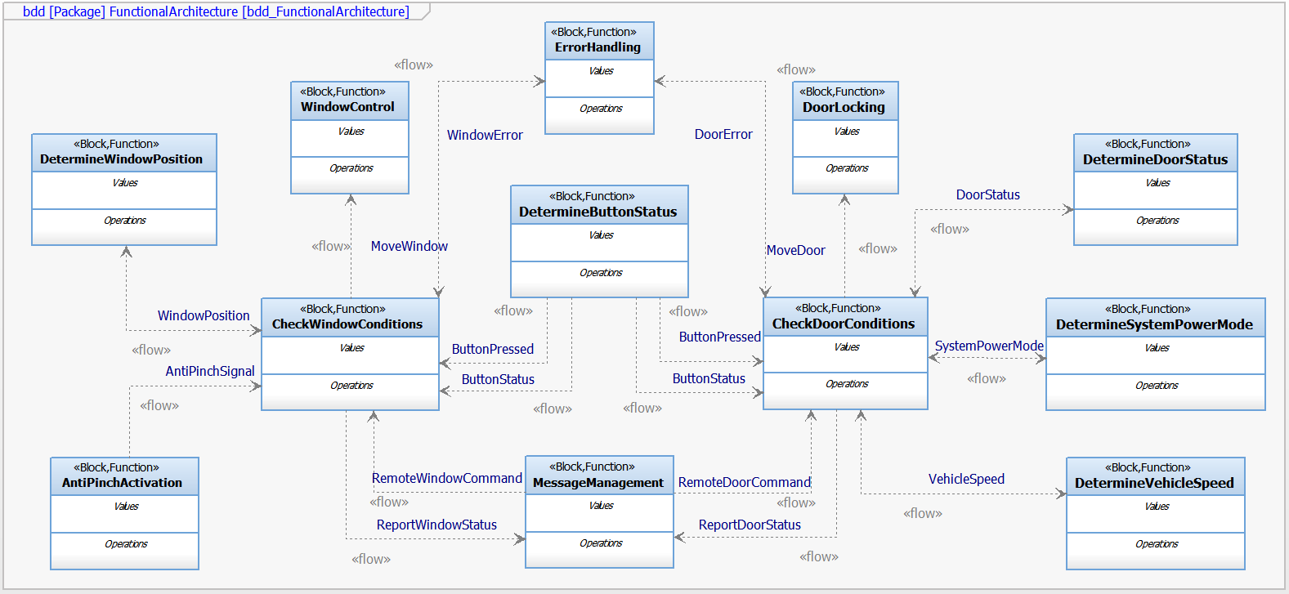

Functional Interaction
This sequence diagram displays the interaction among functions for a Button Pressed Event, leading in a window movement or door locking/unlocking.

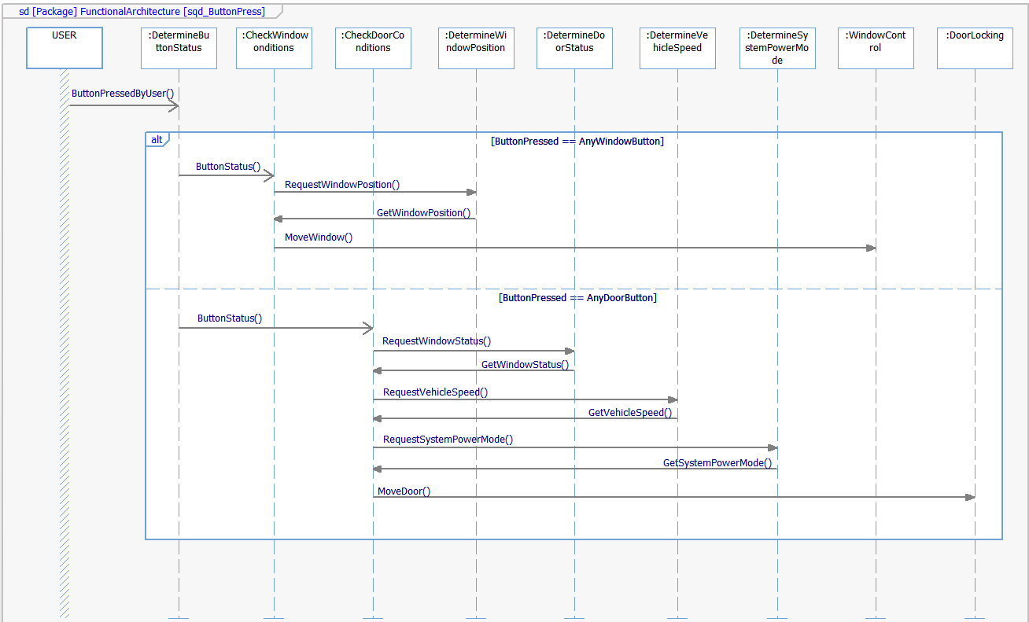

SW Physical Architecture

Physical Decomposition
The SW decomposition diagram indicates the Software Layers and Physical Architecture.

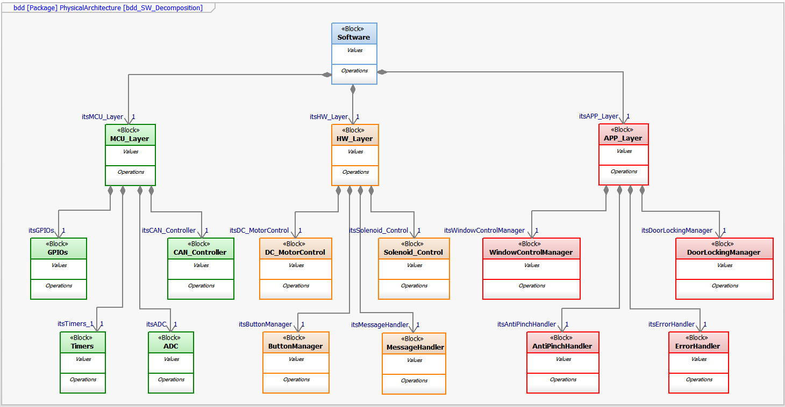

Table of SW components
SWC Name | Description | Estimated Size (KB)
ButtonManager | Checks the button status and identifies the kind of button press. | 20
SolenoidControl | Controls the solenoid to lock or unlock a specific door, according to the corresponding operation mode and variables status. | 20
MotorControl | Controls the mechanical device to open and close an specific window. | 20
MessageHandler | Sends, receives, identify and routes CAN frames. | 25
WindowControlManager | Performs a window action, depending on the window, button, messages and antipinch status. It opens, closes, global opens, global closes, cancels and report error and status of a door. | 30
DoorLockingManager | Performs a door action, depending on the door, button, messages, speed and power mode status. It locks, unlocks, autolock and report error and status of a door. | 30
AntiPinchHandler | Reports an antipinch event. | 20
ErrorHandler | Handles any kind of operation error. | 20

Table of Physical Interfaces
Operation | Description
MoveWindow | Stablishes a new window operation (close, global_close, open, global_open)
NewAntiPinchEvent | Triggers the AntiPinch actions
NewButtonEvent | Notifies which button was pressed and the operation (short, long, stuck)
NewMessageEvent | Notifies new messages coming from the CAN bus
SendMessage | Sends messages through the CAN controller
ChangeDoorStatus | Stablishes a new door operation (lock, unlock)

Physical Interfaces
This block definition diagram stablishes the physical intrefaces that must be implemented to communicate the Door Control Module Software Components, according to the table 5.3.

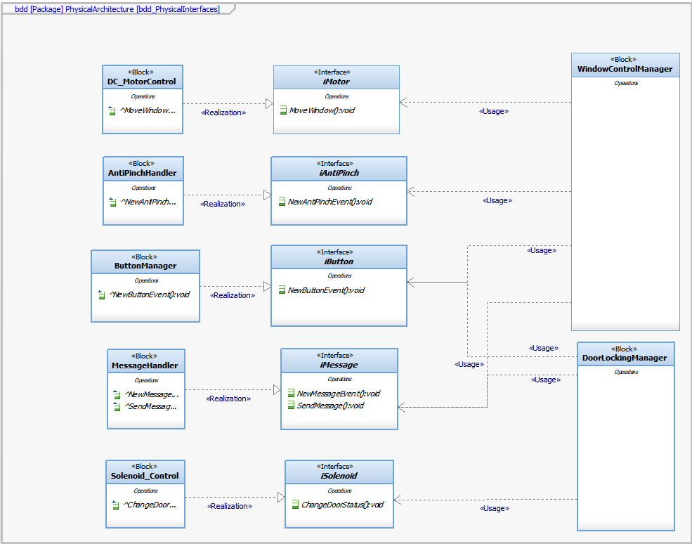

Physical Interaction
This sequence diagram displays the interaction among physical functions for a Button Pressed Event and Message received, leading in a window movement or door locking/unlocking.

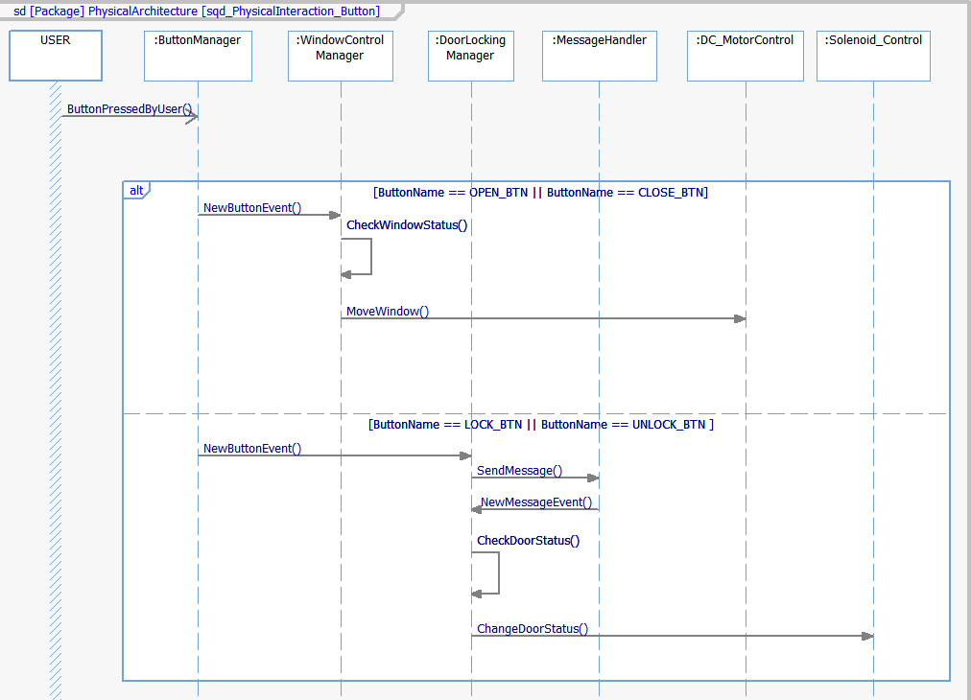
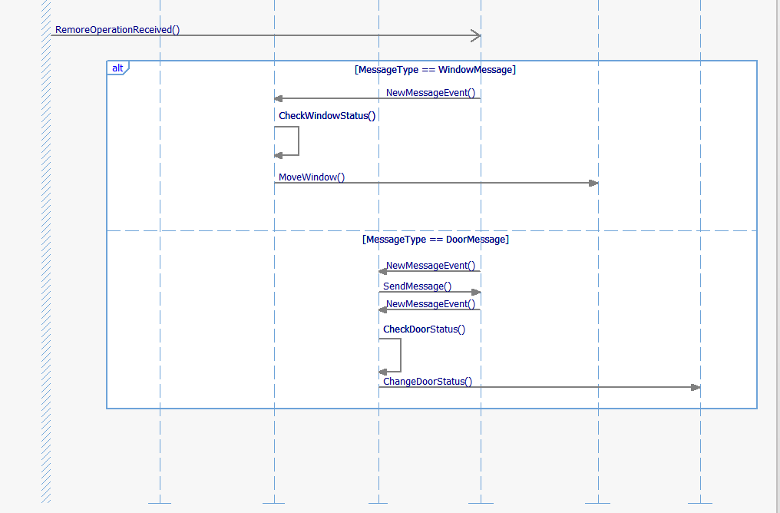

Describe Dynamic Behavior

OS tasks
OS task | Description | Periodicity | Period | Priority | CPU Load
OS_TaskInit |  | No |  | 1
OS_Antipinch | Asynchronous task to report Antipinch Event | Yes |  | 2 | 10%
OS_Error | Asynchronous task to report Error Event | Yes |  | 3 | 10%

Interrupt Handling
ISR task | Description | Priority | CPU Load
ANTIPINCH_ISR | AntiPinch Detection | 1 | 10%
DIGITAL_INPUT_ISR | Button Pressed | 2 | 10%
CAN_RX_ISR | Remote message detected | 3 | 15%

Power Modes

Low Power Mode

N/A

High Power Mode

SW always initialize since there are no low power mode.

Synchronization Mechanisms

Function to Physical Allocation

Function | SW component | Clarification
DetermineButtonStatus | ButtonManager
DoorLocking | SolenoidControl
DetermineDoorStatus | DoorLockingManager
WindowControl | MotorControl
DetermineWindowPosition | WindowControlManager
AntiPinchActivation | AntiPinchHandler
MessageManagement | MessageHandler
DetermineVehicleSpeed | MessageHandler
DetermineSystem  PowerMode | MessageHandler
CheckDoorConditions | DoorLockingManager
CheckWindowConditions | WindowControlManager
ErrorHandling | ErrorHandler

SW Requirements Allocation

In the link, the traceability matrix template will show the SW requirements allocation.

https://github.com/marcovc41/Proyecto_Diplomado/blob/master/V-Cycle%20Process/1.0%20Requirements/Traceability%20Matrix%20Template.xls

SW Integration Plan

Integration Step | Description | SW components | Comments
1 | Button interaction | ButtonManager | Big Bang
2 | CAN bus communication | MessageHandler | Big Bang
3 | Basic window functions | WindowControlManager | Big Bang
4 | Basic Door functions | DoorControlManager | Big Bang
5 | Motor control for window movement | DC_MotorControl | Top Down
6 | Solenoid control for door locking | Solenoid_Control | Top Down
7 | AntiPinch event handling | AntiPinchHandler | Big Bang
8 | Error event handling | ErrorHandler | BigBang

Functional Safety
This chapter will be fill during Module 5

